LearnMate (AI StudyBuddy) - Project Development Phase

Epic 3: Backend Development
The AI StudyBuddy backend is developed using Node.js, Express.js, and MongoDB, following a modular architecture. The application separates routing, controllers, middleware, models, and utility modules to improve code maintainability and scalability. The backend exposes secure REST APIs for authentication, study material management, AI-powered content generation, and administrative operations.

Backend Structure


Core System Script Implementations

1. Application Entry Point (index.js)
The index.js file serves as the main entry point of the application. It initializes the Express server, loads environment variables, configures middleware, establishes the MongoDB connection, registers API routes, and starts the server after a successful database connection.
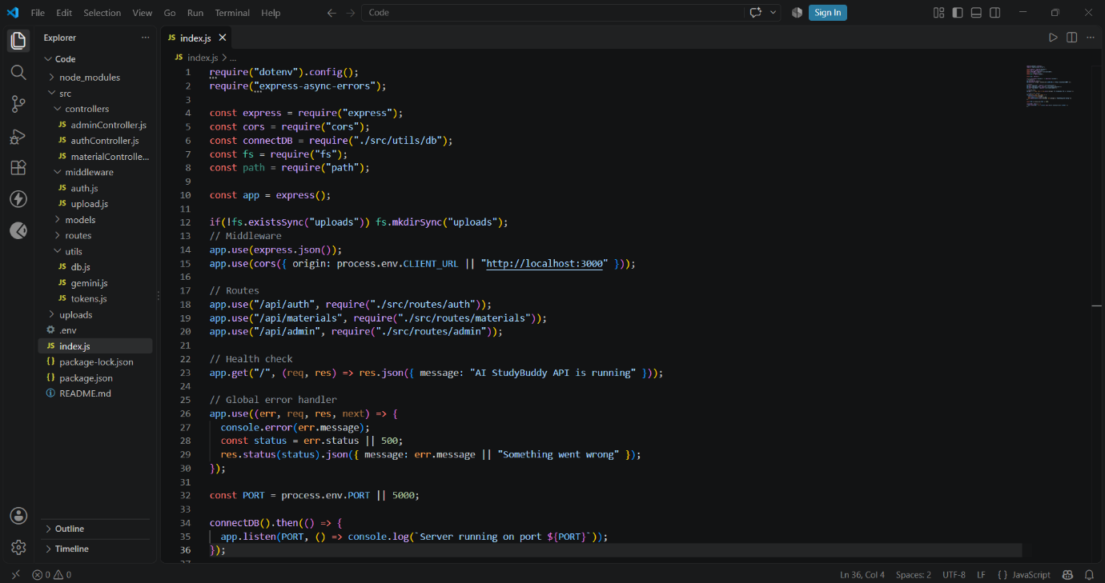

2. Database Connection (src/utils/db.js)
This module establishes a connection between the application and MongoDB using Mongoose. It ensures that the backend communicates with the database before processing any client requests.
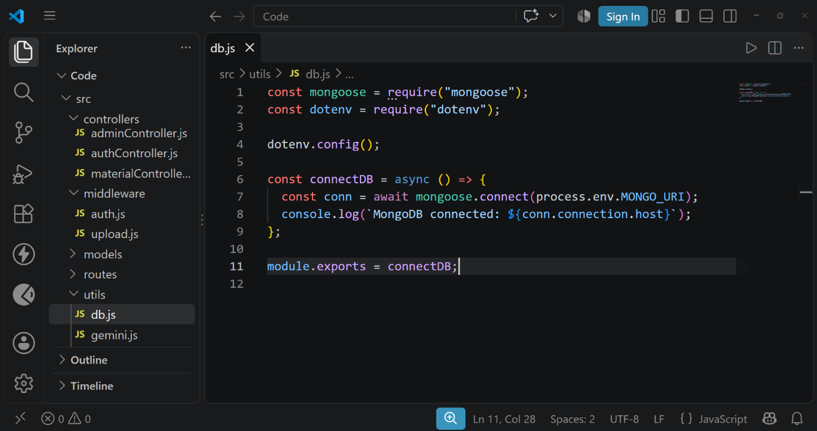

3. Authentication Middleware (src/middleware/auth.js)
The authentication middleware verifies JWT access tokens for protected routes. It authenticates users before granting access to secured APIs and includes role-based authorization to restrict administrative operations.
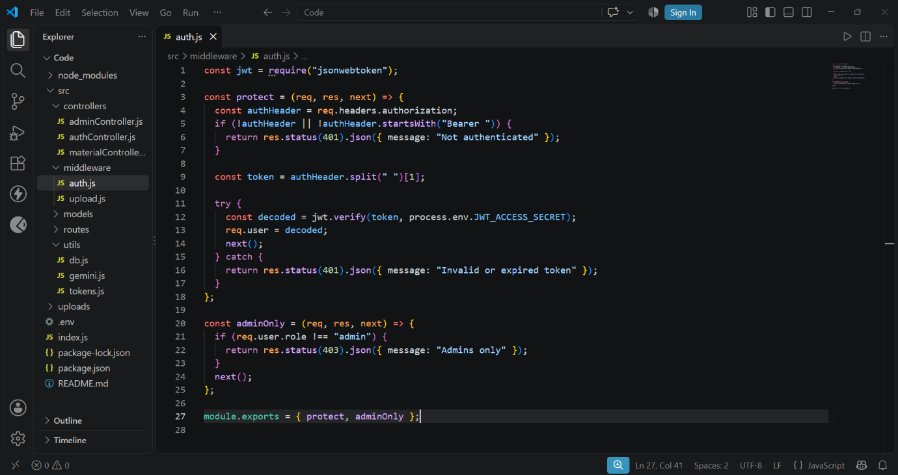

4. AI Integration (src/utils/gemini.js)
This utility integrates the backend with the Google Gemini 3.5 Flash Lite API. It sends prompts to the AI model and returns generated responses for summaries, flashcards, quizzes, and study plans.
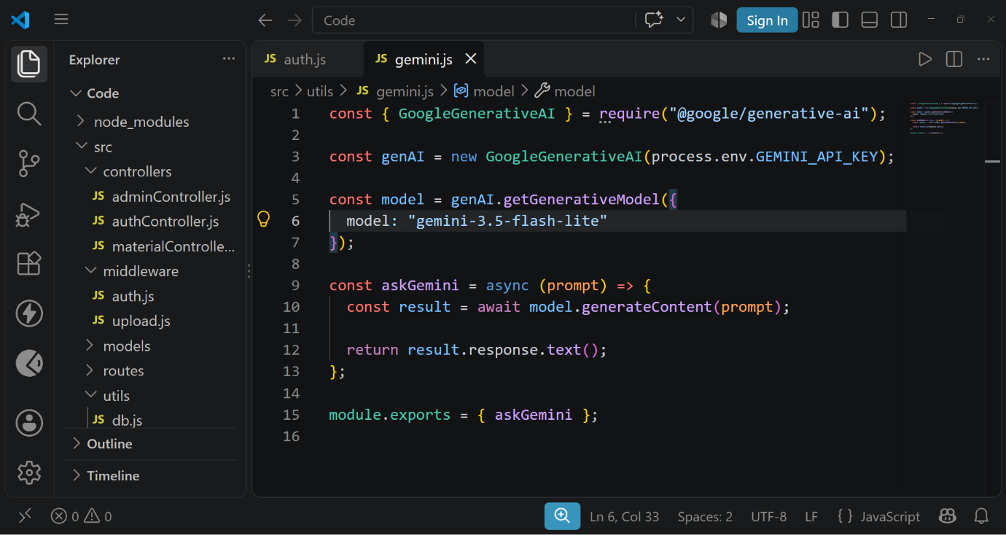

5. File Upload Middleware (src/middleware/upload.js)
The upload middleware handles study material uploads and validates incoming files before they are processed by the backend.

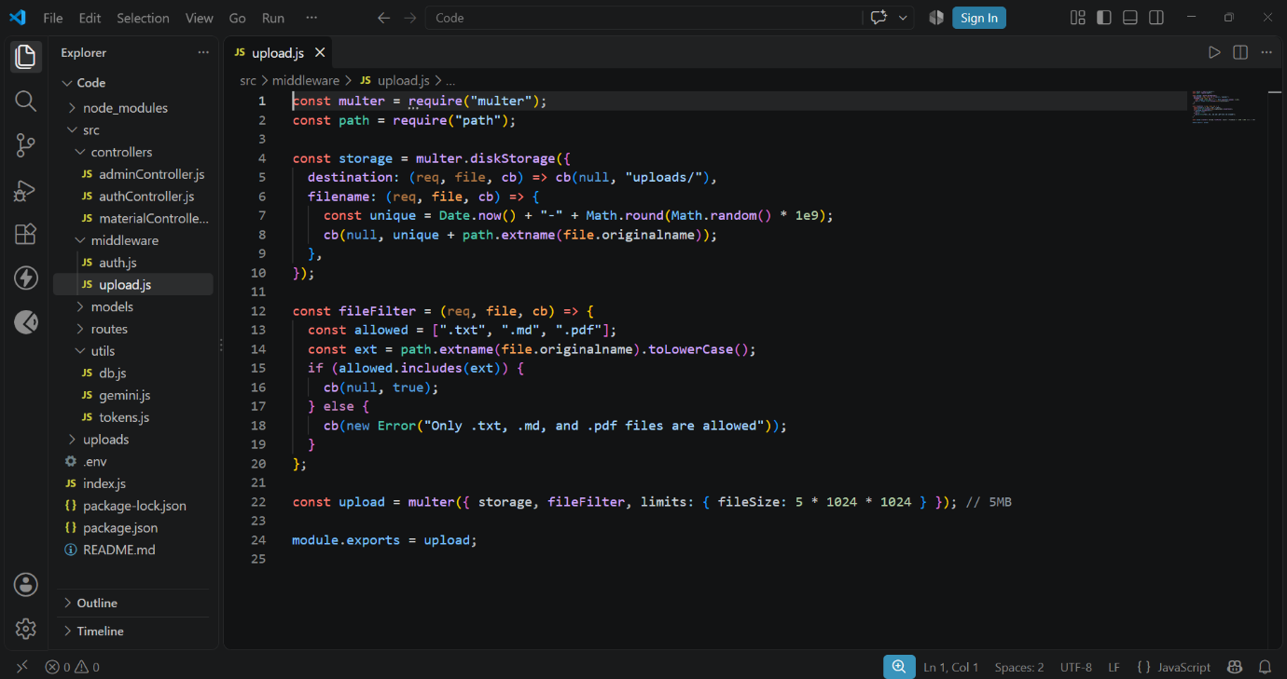

Epic 4: Database Configuration
The AI StudyBuddy backend uses MongoDB as its primary NoSQL database and Mongoose ODM for data modeling and schema validation. MongoDB stores user information, uploaded study materials, and AI-generated learning resources in a structured manner. Mongoose simplifies database operations by providing schemas, validation rules, and efficient query handling.

Configure MongoDB
Install Mongoose using the following command:
npm install mongoose

Create Database Connection
Before performing any database operations, establish a connection between the backend and MongoDB using Mongoose. The connection module is initialized during server startup to ensure reliable communication with the database.

Mongoose Schema Definitions

1. User Schema (models/User.js)
The User schema stores authentication and profile information for registered users. It includes fields such as name, email, password, and role. Passwords are securely encrypted before being stored in the database.
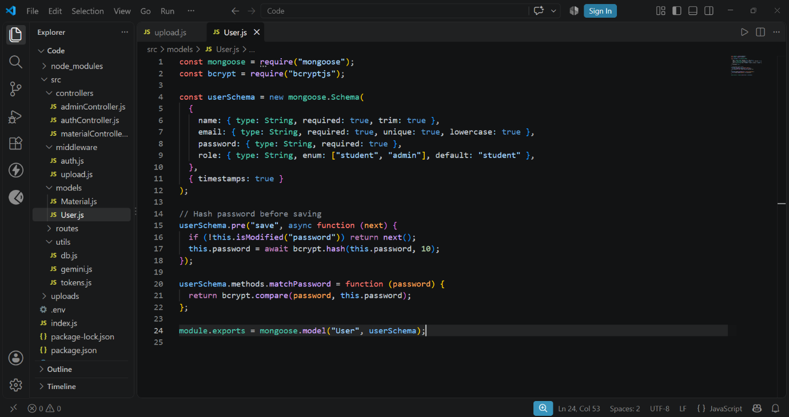

2. Study Material Schema (models/Material.js)
The Study Material schema stores the learning content uploaded by users. This content acts as the input for AI-powered features such as summaries, quizzes, flashcards, and study plans.
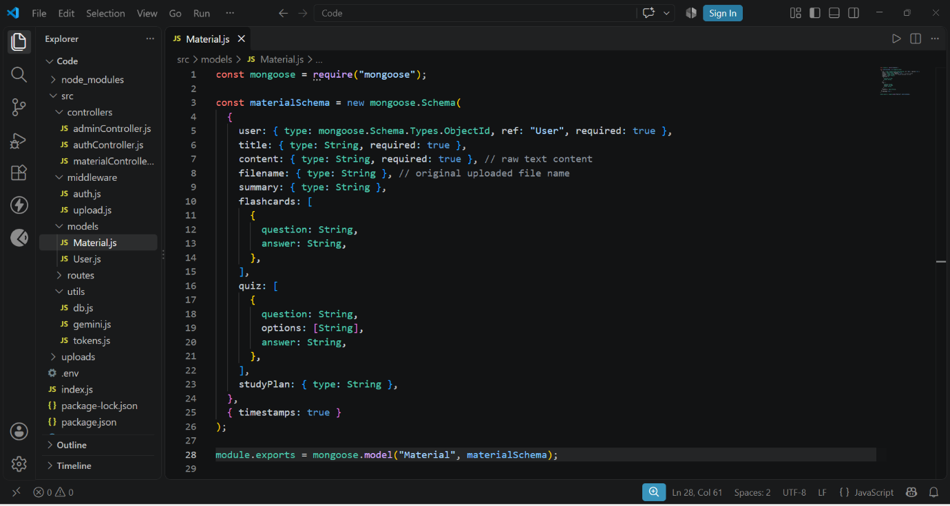

Database Collections
The AI StudyBuddy database consists of the following collections:
- Users – Stores user account and authentication details.
- Study Materials – Stores uploaded learning materials.

